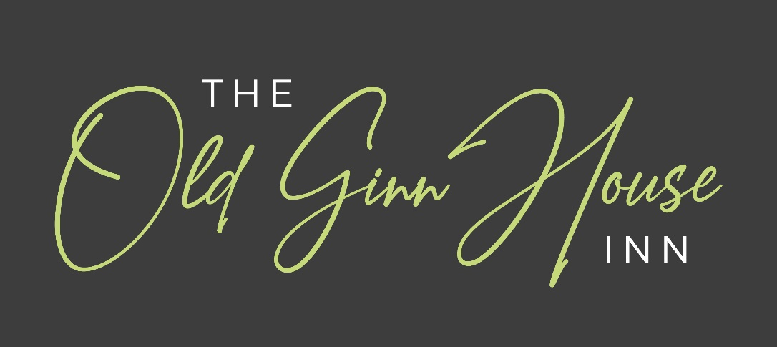
MENU
SERVED MONDAY TO SATURDAY
LUNCHTIMES 12 NOON – 2 PM & EVENINGS 5.30 PM – 9.00 PM
SUNDAY
12 NOON – 9.00 PM

Also –

See our choice of Today’s Specials
&
on Sunday the choice of Roasts

Parties of 10 or more – We are unable to split the bill between individuals as, on occasions, we have not received full payment when customers come and pay individually.
At the end of the evening you will be presented with a detailed bill showing the total for the whole party. Please spilt the bill and organise full payment.
We apologise for any inconvenience that this may cause.
THIS MENU IS AVAILABLE IN LARGE PRINT

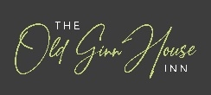

For Great Food & Accommodation

Functions; Parties; Christenings; Funeral Lunches/Teas; Informal Weddings

Our 21 bedrooms are located across the courtyard
from the main bar and dining areas and offer excellent facilities.

Great Clifton Workington CA14 1TS
Tel: 01900 64616
Email: enquiries@oldginnhouse.co.uk
www.oldginnhouse.co.uk

FULL ALLERGEN INFORMATION CAN BE FOUND IN OUR BOOKLET – please ask

Thank you for your patience -
As food is prepared & freshly cooked it may take a little time especially at busy periods

Starters

Soup of the Day £6.25
Chef’s homemade soup served with a crusty roll & butter – please ask for today’s variety

Black Pudding & Bacon Stack £7.50
Served with a drizzle of peppercorn sauce

Creamy Garlic Mushrooms V £7.25
Served with a warm crusty roll

Hoisin Duck Bon Bons £7.50
Served on a bed of lettuce with a teriyaki drizzle

Bruschetta £7.25
Topped with onion marmalade, goat’s cheese & crispy pancetta

Prawns, Smoked Salmon & Marie Rose Sauce £7.75
Succulent cold-water prawns & smoked salmon with Marie Rose sauce on a
bed of crisp lettuce served with brown bread & butter

Garlic & Herb Breaded King Prawns £7.50
Served on a bed of sauté peppers & onions with a teriyaki drizzle

Mango & Brie Parcels £7.25
Served with a salad garnish

Chicken Mini Fillets £7.50
Southern fried tender chicken mini fillets served with a salad garnish
& a choice of sweet chilli dip or barbecue dip or garlic mayo

Mexican Chicken Fajita Spring Rolls £7.50
Served with a salad garnish & tomato chutney

Old Ginn House Platter £20.95
2 x 2oz slider burgers, sticky Korean chicken, sticky Cumberland sausage, garlic & herb breaded king prawns, served with salad & sweet potato fries

Mains
Served with Chips or Creamy Mashed Potatoes or Boiled Potatoes or Sweet Potato Fries & Vegetables of the Day or Salad Garnish, unless otherwise stated
For our Older Children & Senior Diners
* Smaller portions of some main courses available - £2 price reduction

Old Ginn House Favourites

* Local Cumberland Sausage & Fried Egg £17.95

* Old Ginn House Lasagne £17.95
Oven baked layers of pasta & minced steak beef bolognese topped with cheese,
served with chips & garlic bread

* Old Ginn House Steak & Ale Pie £17.95
A rich short crust pie filled with tender pieces of prime steak braised in ale

* Old Ginn House Chicken & Ham Pie £17.95
A rich short crust pie filled with tender pieces of chicken & ham in a creamy sauce

* Gammon Steak 10oz £17.95
Prime gammon with a fried egg & pineapple served with tomato, mushrooms & onion rings

Old Ginn House Mixed Grill £24.95
Not for the faint hearted – large platter of rump steak, pork & lamb chops, gammon,
black pudding, Cumberland sausage, fried egg, tomato, mushrooms & onion rings

Whole Shoulder of Lamb £23.95
Tender whole shoulder of lamb marinated in mint; honey & garlic slowly roasted
served with a rich mint gravy

Old Ginn House Ultimate Burger £20.95
2 x 4oz steak burgers, 4oz chicken breast, bacon, cheese & onion rings served in a premium bun with a salad garnish & chips

* Sweet & Sour Chicken £17.95
Battered pieces of chicken breast in a sweet & sour sauce
served with rice or chips or ½ & ½

Breaded Chicken Escallop £17.95
Served on a bed of pappardelle pasta, tossed in a garlic & parmesan cream & pancetta. Served with garlic bread

Steaks
Served with Tomato, Mushrooms & Onion Rings
(Approx uncooked weight)
All Steaks cooked to your liking

Rump Steak 8oz £19.95
A premium rump

Rump Steak 16oz £24.95
A premium rump

Fillet Steak 8oz £27.50
Tender prime fillet

Steak Sauces £4.25
All of the above steaks can be served with the following sauces:-
Peppercorn or Diane or Stilton

Personalise Your Dish With one of these extras

Wholetail Breaded Scampi £5.95

Black Pudding Slices £4.50

Cumberland Sausage Link £4.50

Fish (Fish may contain small bones)

* Traditional Fish & Chips £16.50
Served with mushy peas

* Lobster, Red Shrimp & Crab Tortellini £19.95
Served with lobster cream & garlic bread

* Wholetail Scampi & Chips £16.50
Deep fried wholetail breaded scampi served with
a salad garnish, lemon wedge & chips

Salmon Fillet & King Prawns £19.25
Served with a honey & sweet chilli glaze garnished with chives

Vegetarian (V)

* Mushroom Stroganoff V £15.95
Mushrooms cooked in a creamy paprika sauce served with rice or chips or ½ rice & ½ chips

* Vegetable Carbonara V £15.95
Pappardelle pasta & mixed vegetables tossed in a garlic & parmesan cream cheese. Served with garlic bread

* Old Ginn House Vegetable Lasagne V £15.95
Layers of pasta with vegetables topped with cheese served with chips & garlic bread

* 5 Bean & Soya Mince Chilli Vegan £15.95
Served with rice

* Jambalaya Vegan £15.95
Spiced rice dish with tomatoes, onion, peppers & beans

Large Salad Platter
Optional choice of salad dressing, served separately

* Meat Platter £16.95
Baked Ham or Roast Beef or Roast Turkey or mixture of all 3
served with a large mixed salad

* Prawn Platter £17.95
Succulent cold-water prawns & Marie Rose sauce served with a
large mixed salad & brown bread

Southern Fried Chicken £16.95
Served with a large mixed salad

Side Orders Add a little extra

Beer Battered Onion Rings V £4.95

Garlic Bread V £4.95
Garlic Bread & Cheese V £4.95
Portion of Real Homemade Chips V £5.25

Sweet Potato Fries V £5.25
Seasoned Potato Wedges V £5.25

Halloumi Fries V £5.25

Lite-Bites
Lunch Time Only Monday - Saturday

Late Breakfast - £14.75
Cumberland sausage, bacon, egg, fried bread, beans, mushrooms & tomato

Omelette served with a Salad Garnish

Plain V £9.25

Cheese V £9.75

Mushroom V £9.75

Prawn £10.25

Ham £9.75

Lite-Bites (cont)
Lunch Time Only Monday - Saturday

Sandwiches
White or Brown Bread served with a salad garnish

Ham £8.25

Turkey with Cranberry £8.25

Cheese & Chutney V £8.25

Tuna Mayo £8.25

Roast Beef £8.25

Classic BLT £8.25

Prawns & Marie Rose Sauce £8.95

Soup & Sandwich Special - £13.50
Soup of the day with any of the above sandwiches

Toasted Rustic Ciabatta served with a salad garnish a salad garnish

Tuna & Cheese Melt £9.95

Southern Fried Chicken Mini Fillets, BBQ Sauce & Cheese Melt £9.95

Bacon & Cheese Melt £9.95

Cumberland Sausage & Red Onion Marmalade £9.95

Beef, Onion & Gravy £9.95

Breakfast – Bacon, Sausage & Egg £9.95

Fish Fingers with Lettuce & Tartare Sauce £9.95

Cheddar Cheese & Tomato V £9.95

Soup & Ciabatta Special £14.50
Soup of the day with any of the above Ciabattas

Puddings & Desserts

Why not leave some room for afters!
Ask for today’s selection of Homemade & Popular Desserts

Puddings/Desserts £7.25

English Lakes Ice Cream Sundae £7.25

English Lakes Ice Cream - small portion £6.15
Please ask for today’s ice cream selection
Special: - Dessert plus Coffee / Tea £8.95
to be ordered together (Excluding Liqueur Coffee)

ALLERGEN INFORMATION FOR PUDDINGS & DESSERTS– please ask

Coffee/Tea

Black Coffee £3.30
White Coffee £3.30
Latte £3.75
Cappuccino £3.75
Espresso £3.30
Espressochoc £3.75
Moccachino £3.75
Hot Chocolate £3.75
Tea £2.95
Fruit Tea £2.95
Liqueur Coffee (eg Irish coffee) £6.75

At the Old Ginn House, wherever possible,
we use fresh local produce from local suppliers

