NEW YEAR'S EVE 2025
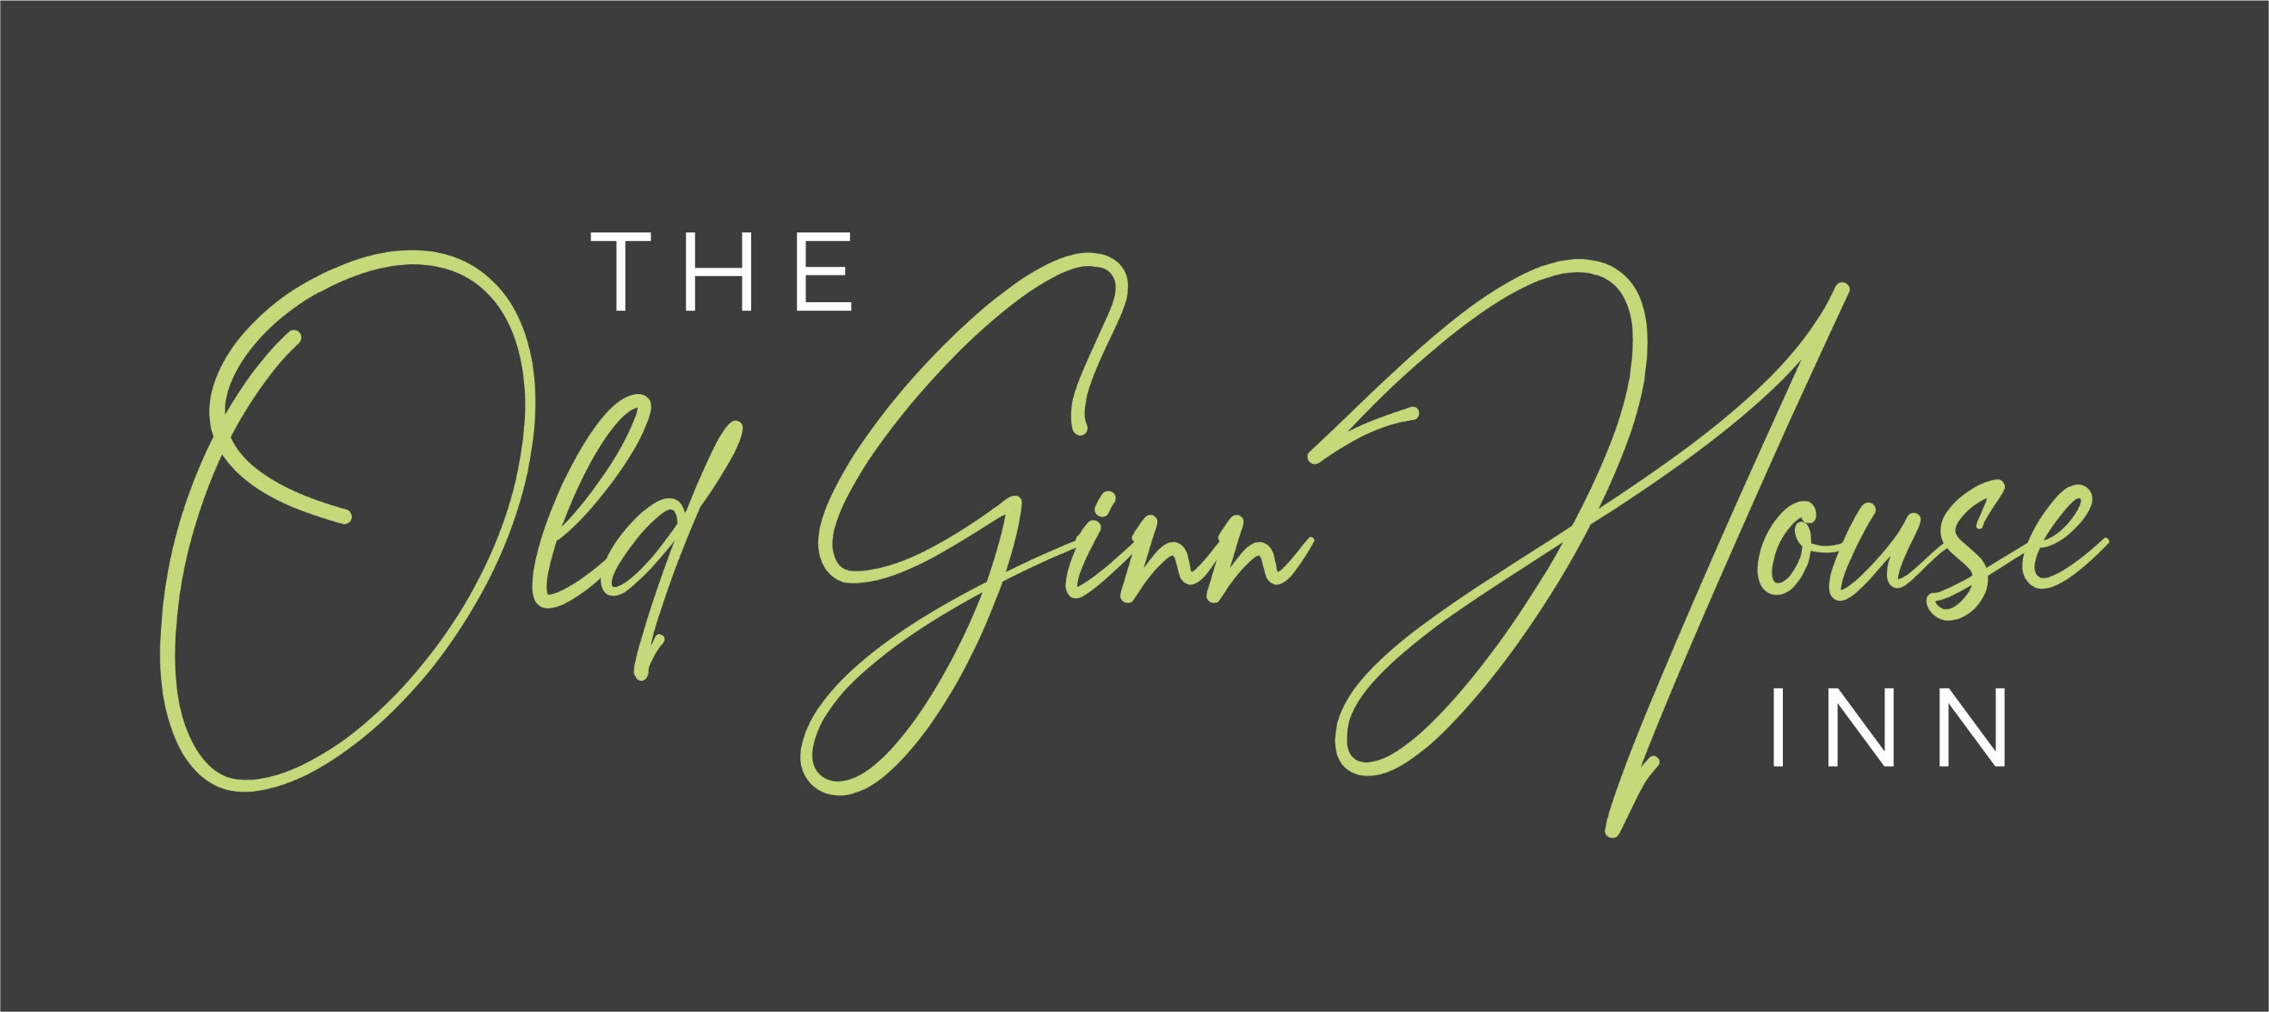

FESTIVE MENU Served 5.30 – 9pm

Order a Main Course Only, 2 Courses or 3 Courses – the Choice is Yours!

Starters

Carrot, Sweet Potato, Lentil & Coconut Soup served

with a Warm Crusty Roll & Butter £6.50

Baked Portobello Mushroom stuffed with Mozzarella & Pesto
with a Parsley Crumb Top £8.25

Trio of Smoked Meats, Smoked Duck Breast, Smoked Chicken Breast & Smoked
Bacon served on a bed of Chilli Jam £8.25

Trio of Fish, Breaded Lemon & Black Pepper Plaice Goujon, Crabcake & a Sweet
Chilli King Prawn £8.50

Haggis & Lorne Sausage Stack served with a drizzle of Whisky Cream £8.25
Potato Skins filled with Cheddar Cheese & Pancetta
with a drizzle of Garlic Aioli £7.95

Main Courses

Leg of Lamb Bavette served with Sweet Potato Mash, Roasted Shallots & Roasted

Baby turnips with a Redcurrant Jus £22.95

16oz Sirloin Steak, cooked to your liking, served with Vine Tomatoes,

Mushrooms, Onion Rings, Salad & Chips £27.95
ADD – Peppercorn Sauce or Stilton Sauce - £3.95

Pork Loin Cannon served on a bed of Roasted Root Vegetables topped with a
Plum, Orange & Rhubarb Sauce £20.95

Rice Bowl – Cantonese Duck, Crispy Battered Shredded Chicken served on a
bed of Rice, topped with Fresh Chilies, Spring Onions, Sesame Seeds & Black
Onion Seeds with a Sriracha drizzle £21.95

Trio of Pork – Belly Pork, Cumberland Sausage & Black Pudding served with Leek

infused Mash Potato, Spring Cabbage & Bacon Cassolette & a side of

Wholegrain Mustard Sauce £23.95

Triple Burger Stack – 4oz Steak Patty, 4oz Chicken Spring Onion & Paprika Patty &

4oz Pork & Chorizo Patty, topped with Spiced Mexican Cheese. Served with Chips,

Salad, Onion Rings & a side of Chipotle Burger Relish £20.50

Christmas Dinner Pie – Turkey & Vegetables in a White Sauce topped with
Stuffing & Pigs in Blankets, encased in short crust Pastry & served with a side of
Vegetables, a pot of Cranberry Sauce, gravy & a choice of Chips or Mash £19.95

(PTO)
NEW YEAR'S EVE 2025

FESTIVE MENU Cont. Served 5.30 – 9pm

Main Courses Cont.

Chicken Breast stuffed with Goats Cheese & Spinach, topped with a Red Pesto

Cream, Served with a side of Vegetables & a choice of Chips or Mash £19.95

Fillet of Beef Medallions served with Honey Roast Parsnips, Roasted Baby Carrots,

Bubble & Squeak & a side of Bearnaise Sauce £26.95

Steak Meatballs served on Rigatoni Pasta topped with a Smoked Paprika Sauce,

Crispy Pancetta & Parmesan Cheese. Served with a side of Garlic Bread £19.95

Lobster & King Prawn Linguine tossed in a Lobster Cream served with Garlic Bread.

Garnished with Fresh Chives & Parmesan £22.95

Skin on Cod Fillet – Pan-Fried Cod Fillet served with Asparagus Spears,

Smoked Cheese Sauce, Crispy Leeks & Pancetta with Chive Crushed New Potatoes £20.95

Vegetarian Jamaican Curry – Sweet Potato, Green Beans, Peppers & Onions in a

Jamaican style Curry Sauce topped with Pineapple & served with Rice £18.95

Roasted Butternut Squash, filled with Cranberry & Goats Cheese served on a £18.95
bed of Ratatouille & with a side of Toasted Sourdough

Desserts

Old Ginn House Sticky Toffee Pudding – our own version of this popular Date Pudding £7.95
served warm with hot Butterscotch Sauce & Double Jersey Ice-cream

Old Ginn House Strawberry & Rhubarb Crumble served with Custard £7.95

Old Ginn House Warm Triple Chocolate Brownie served with Cookies &
Cream Ice-cream £7.95

Old Ginn House After Eight & Ferrero Roche Cheesecake served with Double Cream £7.95

Old Ginn House Mixed Fruit Pavlova served with Double Cream £7.95

English Lakes Ice Cream Sundae – a choice of Double Jersey, Thunder &
Lightening, Crushed Strawberry or Death by Chocolate £7.95

Special: - Dessert plus Coffee/Tea £9.50
to be ordered together (Excluding Liqueur Coffee)

Families Welcome - Children’s Menu Also Available
ALLERGEN INFORMATION – PLEASE ASK

The Old Ginn House Inn Great Clifton Workington CA14 1TS

Tel: 01900 64616 E-mail: enquiries@oldginnhouse.co.uk www.oldginnhouse.co.uk

